**Instructıons for use the program Python**

**Name : Modou Fadilou Fall**

**Group : B1**

Hi, I will show you how to use and what it’s for the program Python.

**Explanation of codes :**

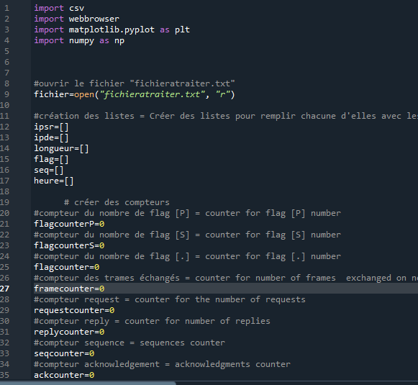

With these codes I create tables and counters .

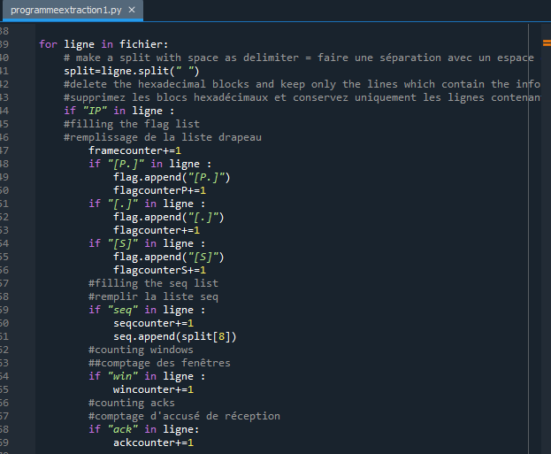

with these codes I record flags, sequences, acknowledgements in the predefined tables.

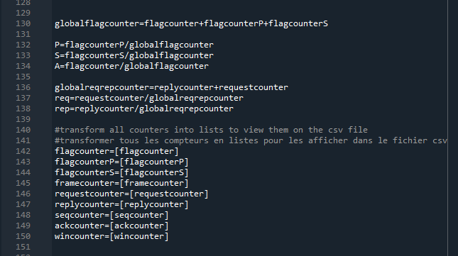

I transform all data into list groups for the csv file.

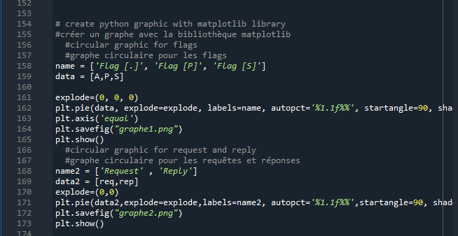

**this code allows to make two pie charts: one for flags and the other for request and reply.**

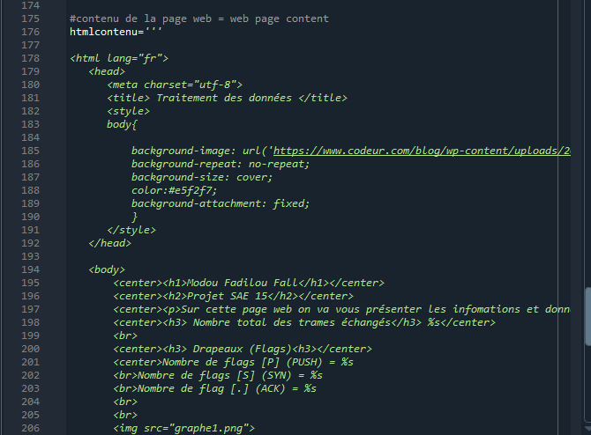

**this code allows to generate an html file and put all the statistics.**

**It result:**

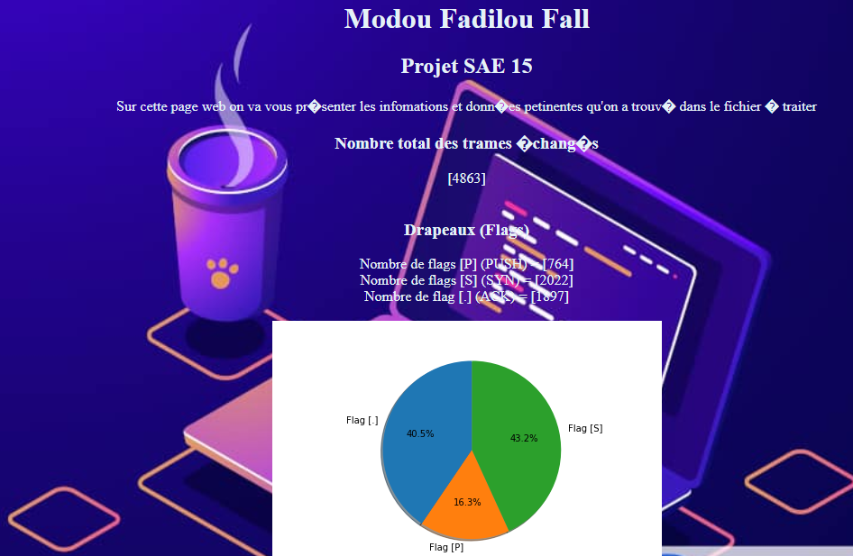

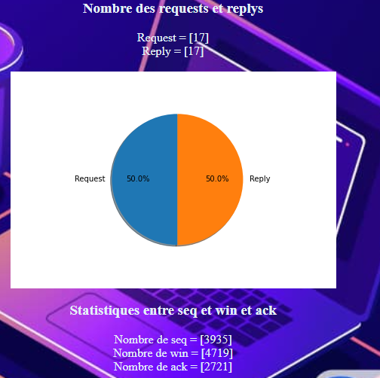

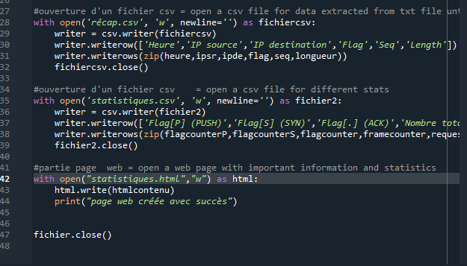

**this code allows to create two csv files by putting on one all the information and on the other, the flags, reply, request... and the html file.**

**for the file recap.csv we have:**

